# **Hospital Information System**

A Patient Management System and an Appointment Management System are integral components of healthcare information technology that help healthcare providers streamline their operations, enhance patient care, and improve overall efficiency. Let's delve into each system.

## Patient Management System:

A Patient Management System (PMS) is a comprehensive software solution designed to manage various aspects of patient information, records, and interactions within a healthcare facility. It is a central repository for storing and retrieving patient data, facilitating communication between different departments, and ensuring the continuity of care.

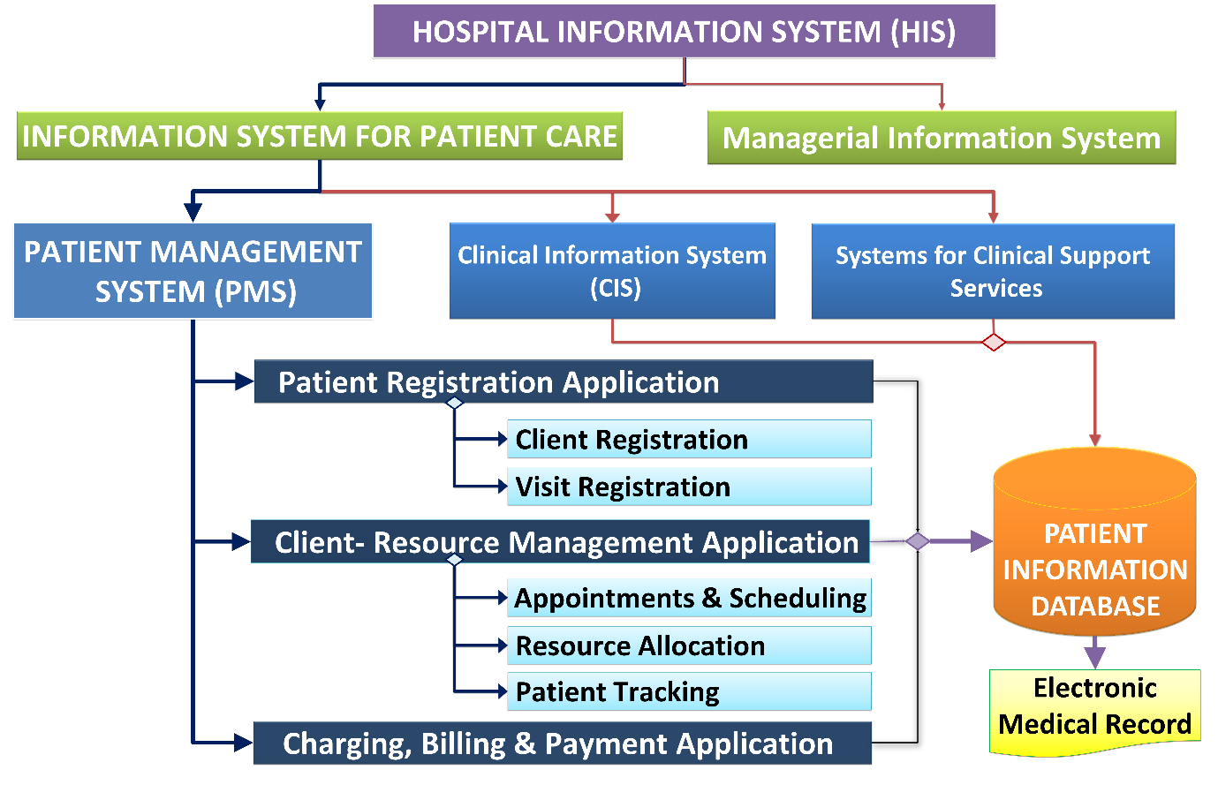

*Key Features:*

1. Patient Demographics: Captures and maintains essential patient information, including personal details, medical history, and contact information.
2. Scheduling and Appointments: Assists in scheduling patient appointments, managing appointment calendars, and sending reminders.
3. Billing and Insurance: Tracks billing and insurance information, handles claims processing, and generates financial reports.
4. Electronic Health Records (EHR): Stores and organizes patient health records, facilitating easy access for healthcare providers.
5. Prescription Management: Manages prescriptions, medications, and pharmacy-related information.
6. Reporting and Analytics: Provides tools for generating reports and analyzing patient data to support decision-making.

*Benefits:*

1. Efficient Workflow: Streamlines administrative tasks, reducing paperwork and manual errors.
2. Improved Patient Care: Enhances the quality of patient care by providing quick access to accurate patient information.
3. Compliance: Helps healthcare facilities adhere to regulatory requirements and standards.
4. Communication: Facilitates communication between different healthcare professionals and departments.

## Tables loaded

**1. Core Patients:**

- Contains detailed patient information such as age, gender, citizenship, insurance status, etc.

**2. Lookup Countries:**

- Stores information about countries, including country ID, country name, and country ISO number.

**3. Core PatientForms**

**-** It contains all the formInstanceID (feedback form, complaint form etc..) of the forms

**4. DynamicForms FieldTemplateValues**

**-** It stores field template ID, field instance ID which are the field values of the forms

**5. DynamicForms FieldTemplates**

- It contains all the names of the forms

## Transformations Done

Core Patients

**1. Gender Description Column:**

* + Add a new column named "Gender Description."
  + Use the following logic:
  + If Gender column value is 1, set "Male" in the Gender Description column.
  + If Gender column value is 2, set "Female" in the Gender Description column.
  + For any other values in the Gender column, set "Other" in the Gender Description column.

**2. Residence Type Description Column:**

* Add a new column named "Residence Type Description."
* Use the following logic:
* If Residence Type column value is 1, set "Citizen" in the Residence Type Description column.
* For any other values in the Residence Type column, set "Visitor" in the Residence Type Description column.

**3. Blood Group Description Column:**

* Add a new column named "Blood Group Description."
* Use the following logic:
* If Blood Group column value is 0, set "O -ve" in the Blood Group Description column.
* If Blood Group column value is 1, set "O +ve" in the Blood Group Description column.
* If Blood Group column value is 2, set "A -ve" in the Blood Group Description column.
* If Blood Group column value is 3, set "A +ve" in the Blood Group Description column.
* If Blood Group column value is 4, set "B -ve" in the Blood Group Description column.
* If Blood Group column value is 5, set "B +ve" in the Blood Group Description column.
* If Blood Group column value is 6, set "AB -Ve" in the Blood Group Description column.
* If Blood Group column value is 7, set "AB +ve" in the Blood Group Description column.

**4. Marital Status Description Column:**

* Add a new column named "Marital Status Description."
* Use the following logic:
* If Marital Status column value is 1, set "Single" in the Marital Status Description column.
* If Marital Status column value is 2, set "Married" in the Marital Status Description column.
* If Marital Status column value is 3, set "Divorced" in the Marital Status Description column.
* If Marital Status column value is 4, set "Widow" in the Marital Status Description column.
* If Marital Status column value is 5, set "Separated" in the Marital Status Description column.
* For any other values in the Marital Status column, set null in the Marital Status Description column.

**5. Removed Unnecessary Columns:**

Kept necessary columns only

**6. Extracted Date_only Column:**

* Add a new column named "Date_only."
* Extract the date part from the "Created Date" column and set it in the "Date_only" column.

**7.Extracted DOB Date column:**

* Add a new column named "DOB Date” Column."
* Extract the date part from the "DateOfBirth" column and set it in the "DOB Date" column.

**8.Created Age column:**

* Calculated age by subtracting created date minus DOB Date and set it as whole number

**9.Created residence column:**

* Calculated residency type like residence, citizen and visitor by below formula
* if [ResidenceType] = 1 and [NationalityID] = 179 then "citizens" else if [ResidenceType] = 1 and [NationalityID] <> 179 then "residence" else if [ResidenceType] = 2 then "visitors" else null

**10.Created Cash | Insurance | Charity :**

* Created a column to classify cash, insurance and charity as
* Insurance Compnay ID <> null then insurance
* Noninsurance company ID <> null then charity
* Else cash

Lookup Countries

Kept necessary columns

Core PatientForms

Kept necessary columns

Merged with dynamicFormsFieldTemplatesValues with left outer join by common column forminstanceID, to get fielValue and field template id which will give us the field values of the forms

Again, merged with dynamicformsfieldtemplates with inner by fieldtemplateid from the left table and formtemplateID from the right table to get the field template name which is nothing but the form name.

DynamicForms FieldTemplates

Kept necessary columns

DynamicForms FieldTemplateValues

Kept necessary columns

Sort Table:

Sort table is created to sort the values in a desired manner

|  |  |
| --- | --- |
| Id | Age Group |
| 1 | infants |
| 2 | children |
| 3 | teens |
| 4 | young adults |
| 5 | adults |
| 6 | seniors |

## Data Modelling

**1. Connection between Calendar Table and Core Patients:**

- Connect the "Date" column of the Calendar table with the "Date_Only" column of the Core Patients table to establish a one-to-many relationship.

**2. Connection between Core Patients and Lookup Countries:**

- Connect the "NationalityID" column of the Core Patients table with the "CountryID" column of the Lookup Countries table to form a many-to-one relationship.

**3. Connection between Core Patients and Core PatientForms:**

- Connect the "PatientID" column of the Core Patients table with the corresponding column in the Core PatientForms table to establish a one-to-many relationship.

**4. Connection between Core Patients and Sort Table:**

- Connect the "Age Group" column of the Core Patients table with the corresponding column in the Sort Table to form a many-to-one relationship.

## DAX Formulas Used:

Patients = COUNT('Core Patients'[PatientID])

field value count = CALCULATE(COUNT('Core PatientForms'[join.FieldValue]))

## Page Layout:

Height : 1150

Width : 1500

## Calculated Columns:

**Calendar table**

Calendar =

  CALENDAR(

        MIN('Core Patients'[CreationDate].[Date]),

        MAX('Core Patients'[CreationDate].[Date]) )

Day = DAY('Calendar'[Date])

Month = MONTH('Calendar'[Date])

Month_name = FORMAT('Calendar'[Date],"mmm")

Quarter = "Q"&QUARTER('Calendar'[Date])

week = WEEKDAY('Calendar'[Date])

Year = YEAR('Calendar'[Date])

**Core Patients**

Age (groups) is created by binning ages,

0-2 infants

3-12 children

13-19 teens

20-35 young adults

36-59 adults

60 & above seniors

## Visualization:

Title:

Selected a text card visualization to insert the title text

Formatted the title of the visual with segoe ui with size 18, bold setting applied and with black colour

Formatted the text with font din with size 8, italic setting and with black colour

Year and month slicer:

Year and month slicers are visualized with year and month column of calendar table to filter the data by year and months.

Dropdown style is applied to both slicers

Slicer header text is formatted with font segoe ui 9 with bold setting and with black colour.

Values is formatted with fond segoe ui , size 9 and with black colour.

Background is turned off for both slicers and header icon is turned on

Patients:

Kpi card is visualised with measure “patients”, this will show the total registered patients with the health care providers.

Callout value is set with font DIN with size 25 and display units none

Text wrap is enabled

Background is enabled and set to white colour

Tooltip is turned on to show default field names

Title is formatted with font segoe Ui with size 13 and subtitle with segoe ui with size 8, text wrap is enable for both title and sub title.

Divider between title and visualisation is turned on to separate things

Patient Registration trend:

A trendline is featured in the dashboard with patients measure on x-axis and year, month and day on y axis to get the patient registration trend over time.

Titles for both the axes are turned off.

Axes values are formatted with font family segoe ui with size 9

Data labels are turned on and position is set to “Auto”, values are formatted with segoe ui font and size 9 with bold setting turned on

Tooltip is turned on to show default field names

Background is turned on and set it as white colour.

Both title and subtitle is turned on and formatted with segoe ui font and sizes 13 and 8 respectively and bold and italic settings are set to title only.

Divider between title and visualisation is turned on to separate things

Distribution of patients across different age groups:

A clustered chart is visualised with patient measure on x-axis and age group column from sort table on y-axis to see distribution of ages group of patients.

Titles for both the axes are turned off.

Axes values are formatted with font family segoe ui with size 9

Data labels are turned on and position is set to “Auto”, values are formatted with segoe ui font and size 9 with bold setting turned on

Tooltip is turned on to show default field names

Background is turned on and set it as white colour.

Both title and subtitle is turned on and formatted with segoe ui font and sizes 13 and 8 respectively and bold and italic settings are set to title only.

Divider between title and visualisation is turned on to separate things

Patients by gender:

A pie chart is visualized with measure patients on values and gender column from core patients on legend.

Legend is turned on and set at top centre position, values formatted with font segoe ui size 10

Detail labels is turned on and position is set as outside and label content is set as data value, percent of total

Tooltip is turned on to show default field names

Background is turned on and set it as white colour.

Both title and subtitle is turned on and formatted with segoe ui font and sizes 13 and 8 respectively and bold and italic settings are set to title only.

Divider between title and visualisation is turned on to separate things

Slices colours are set as

For female #F3D9DC

Male #B0D0D3

Other #E27396

Patients demographic overview:

A pie chart is visualized with measure patients on values and residence column from core patients on legend.

Legend is turned on and set at top centre position, values formatted with font segoe ui size 10

Detail labels is turned on and position is set as outside and label content is set as data value, percent of total

Tooltip is turned on to show default field names

Background is turned on and set it as white colour.

Both title and subtitle is turned on and formatted with segoe ui font and sizes 13 and 8 respectively and bold and italic settings are set to title only.

Divider between title and visualisation is turned on to separate things

Slices colours are set as

For citizens #E5989B

Residence #118DFF

Visitors #FFCDB2

Distribution of patients across various countries:

A stacked bar chart is visualised with patient measure on x-axis and countries column from lookup countries on y-axis to see distribution of patients across the countries.

Titles for both the axes are turned off.

Axes values are formatted with font family segoe ui with size 9

Data labels are turned on and position is set to “Auto”, values are formatted with segoe ui font and size 9 with bold setting turned on.

Tooltip is turned on to show default field names

Background is turned on and set it as white colour.

Both title and subtitle is turned on and formatted with segoe ui font and sizes 13 and 8 respectively and bold and italic settings are set to title only.

Divider between title and visualisation is turned on to separate things

Patients by blood group:

A clustered column chart is visualised with patient measure on x-axis and blood group description column from core patients on y-axis to see distribution of patients across the countries.

Titles for both the axes are turned off.

Axes values are formatted with font family segoe ui with size 9

Data labels are turned on and position is set to horizontal, values are formatted with segoe ui font and size 9 with bold setting turned on

Tooltip is turned on to show default field names

Background is turned on and set it as white colour.

Both title and subtitle is turned on and formatted with segoe ui font and sizes 13 and 8 respectively and bold and italic settings are set to title only.

Divider between title and visualisation is turned on to separate things

How do you know about us:

A clustered bar chart is visualised with patient measure on x-axis and field value column from core patientForm to see how many patients got to know about us by which field.

Titles for both the axes are turned off.

Axes values are formatted with font family segoe ui with size 9

Data labels are turned on and position is set to “auto”, values are formatted with segoe ui font and size 9 with bold setting turned on

Tooltip is turned on to show default field names

Background is turned on and set it as white colour.

Both title and subtitle is turned on and formatted with segoe ui font and sizes 13 and 8 respectively and bold and italic settings are set to title only.

Divider between title and visualisation is turned on to separate things

Patients by billing segment:

A pie chart is visualized with measure patients on values and ‘cash | Insurance | Charity’ column from core patients on legend.

Legend is turned on and set at top centre position, values formatted with font segoe ui size 10

Detail labels is turned on and position is set as outside and label content is set as data value, percent of total

Tooltip is turned on to show default field names

Background is turned on and set it as white colour.

Both title and subtitle is turned on and formatted with segoe ui font and sizes 13 and 8 respectively and bold and italic settings are set to title only.

Divider between title and visualisation is turned on to separate things

Slices colour are set as

For citizens #E5989B

Residence #118DFF

Visitors #FFCDB2